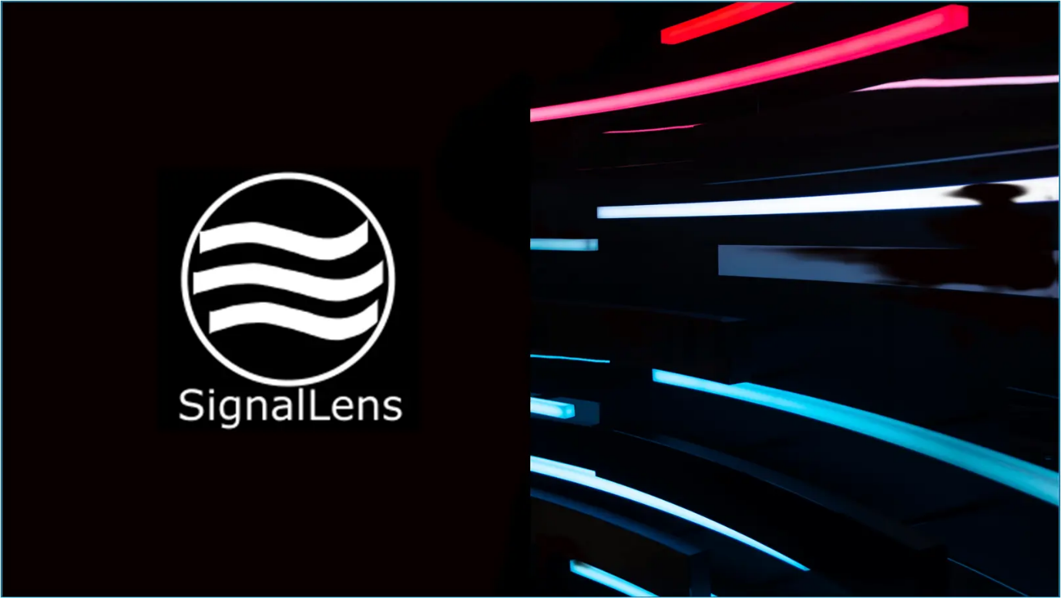

SignalLens 0.0.1-beta is now available for early-access testing

SignalLens, the local visual-forensics tool for explainable image analysis, is now available as a Windows early-access beta.

SignalLens is not designed as a simple ‘AI detector’. Nor does it pretend to be a truth machine.

Instead, it analyses multiple forensic signals and produces an explainable audit trail that helps users to reason about camera-origin evidence, synthetic-generation indicators, editing traces, metadata, and conflicting signals.

Even in this first beta, SignalLens already includes a broad set of analysis capabilities.

It is not distributed as a collection of Python scripts that need to be run manually by specialists. Instead, it offers a complete local GUI experience built with the Qt framework.

Local image analysis can optionally start with OSINT, exploring an unknown image’s possible background through reverse image search. Metadata analysis is supported through ExifTool, revealing invisible information about image creation, editing, software traces, camera data, and embedded workflow clues.

Frequency-domain analysis using FFT and patch-similarity analysis can help detect anomalies in suspect textures and repeated structures. MediaPipe-based segmentation is used for subject/background and boundary-region investigation, helping SignalLens examine localized manipulations such as generative fill, inpainting, or face replacement.

To make these signals inspectable, SignalLens produces visual overlays, masks, heatmaps, JSON outputs, summaries, and a full local audit trail for every analysed image.

Each audit trail documents the evidence behind the conclusion, including a reasoning trace that explains the final interpretation.
SignalLens is still beta software. The executable is unsigned, Windows may show a SmartScreen or Smart App Control warning, and results should be interpreted as forensic reasoning rather than absolute proof.

The download is available here.

Feedback is very welcome, especially from users working in OSINT, journalism, computer vision, image analysis, platform moderation, e-commerce, or synthetic media research.

LinkedIn Version

SignalLens 0.0.1-beta is now available for early-access testing

Over the past months I’ve been building SignalLens: a local visual-forensics tool for explainable image analysis.

The project started from a simple frustration. Most AI image detectors still reduce an increasingly complex problem to a single score.

But modern images are rarely that simple.

A real photograph can contain computational photography artifacts, compression traces, editing, enhancement, segmentation, or platform processing.

A synthetic image can imitate camera noise, metadata, photographic texture, and realistic lighting.

And many images are now hybrids.

So SignalLens does not try to act as a simple ‘AI detector’ or truth machine.

Instead, it analyses multiple forensic signal domains and creates a local audit trail that helps users to reason about:
- camera-origin evidence;
- synthetic-generation indicators;
- editing traces;
- metadata and provenance;
- subject/background inconsistencies;
- conflicting signals.

The current Windows beta includes:
- local image analysis;
- metadata analysis through bundled ExifTool;
- FFT and patch-similarity analysis;
- MediaPipe-based subject/background segmentation;
- visual overlays, masks and heatmaps;
- JSON, text and HTML summaries;
- a reasoning trace explaining the final interpretation.

It is still beta software.
The executable is currently unsigned, so Windows may show a SmartScreen or Smart App Control warning. The results should be interpreted as forensic reasoning, not absolute proof.

Feedback is very welcome, especially from people working in OSINT, journalism, computer vision, image analysis, platform moderation, e-commerce, or synthetic media research.

Download / early-access details are now available on the SignalLens page.

#VisualForensics #ImageAnalysis #ComputerVision #OSINT #SyntheticMedia #SignalLens

Reddit

r/sideprojects
I built a local visual-forensics beta for explainable image analysis

I built SignalLens, a local visual-forensics tool for explainable image analysis.

The motivation came from a frustration with current AI image detectors.
Most of them still reduce an increasingly complex problem to a single score:
“AI-generated: 87%”

But modern images are rarely that simple.

A real smartphone photo can contain computational photography artifacts, HDR, denoising, sharpening, compression, segmentation, and platform processing.

A synthetic image can imitate camera noise, photographic texture, metadata, and realistic lighting.

And many images are now hybrids: generated, edited, upscaled, recompressed, partially real, partially synthetic.

So SignalLens is not designed as a simple “AI detector” or truth machine.
Instead, it analyses multiple forensic signals and produces a local audit trail that helps users to reason about:
- camera-origin evidence;
- synthetic-generation indicators;
- editing traces;
- metadata and provenance;
- subject/background inconsistencies;
- conflicting signals.

The current Windows beta includes:
- local image analysis;
- metadata analysis through bundled ExifTool;
- FFT and patch-similarity analysis;
- MediaPipe-based subject/background segmentation;
- visual overlays, masks and heatmaps;
- JSON, text and HTML summaries;
- a reasoning trace explaining the final interpretation.

It is still early beta software. The executable is currently unsigned, so Windows may show a SmartScreen or Smart App Control warning. Results should be interpreted as forensic reasoning, not absolute proof.

I’ve made the early-access beta available here.
I’d really appreciate feedback, especially from people working with OSINT, journalism, computer vision, image analysis, moderation, e-commerce, or AI-generated image workflows.

That signals as witnesses framing is close to how I’m starting to think about it.
Each signal should probably carry at least three things: what it observed, how confident it is, under which conditions it tends to fail.

A patch-recurrence signal, for example, should not mean the same thing in a tiled architectural scene, a decorative textile, a compressed social-media image, and a generated portrait. The signal itself may fire, but its evidentiary weight could differ.

I agree on provenance-first. If there is credible provenance (signed capture, C2PA, chain-of-custody information, consistent camera metadata), that should reduce the burden placed on texture-based heuristics. Not because provenance is perfect, but because visual heuristics are often fragile.

The counterfactual point is interesting. Feels like a useful auditability requirement. A report should say which signals contributed, but also expose assumptions or thresholds.
That may make the arbitration layer inspectable.

